# 

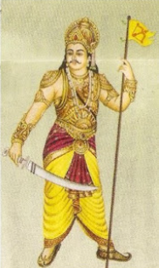 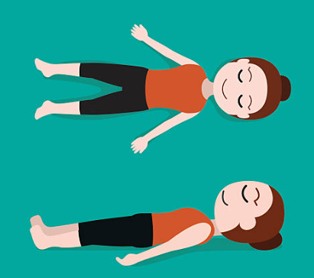

# A cover of a book Description automatically generated A painting of a person sitting on a table Description automatically generatedA painting of a person sitting on a pedestal Description automatically generated A person holding a sword Description automatically generated

# 



